Reclaiming_the_Algorithmic_Margin_Green_Fintech
CONFERENCE PAPER · GREEN FINTECH · EPISTEMIC TECHNO-JUSTICE
Reclaiming the Algorithmic Margin
A Green Fintech Justice Matrix for Climate Finance in the Age of Frontier Technologies
ABSTRACT
Green fintech promises to steer capital toward decarbonisation through AI credit scoring, satellite-verified carbon markets, parametric climate insurance and tokenised green bonds. Yet the same stack can create a green margin paradox: the communities most exposed to climate risk are priced out of climate finance, their data is harvested without reciprocity, and the compute that powers the system displaces its carbon and water costs onto the periphery. Existing governance treats this as an access gap to be closed with more coverage and more apps. This paper argues that the problem is structural. We introduce the Green Fintech Justice Matrix (GFJM), integrating Critical Race and Legal Theory, Decolonial Computing, Political Ecology and Sustainable Finance with Indigenous Epistemology. We redefine digital marginality as green algorithmic enclosure, introduce four measurable constructs (Green Margin Gap, Carbon Redlining Index, Compute-Carbon Ratio, Algorithmic Green Sovereignty Score), and propose four institutional interventions: community protocol audits, green data trusts, carbon-budgeted models and algorithmic recourse. An illustrative simulation shows how GFJM governance could shrink the pricing gap between low- and high-vulnerability borrowers from 8.7 to 2.1 percentage points. The word margin is deliberate: we reclaim the social margin and the financial margin together.
Keywords: green fintech, digital marginality, algorithmic enclosure, carbon redlining, epistemic techno-justice, green data sovereignty, decolonial AI, climate finance

8.7 → 2.1 pp  Green Margin Gap, high- vs low-vulnerability borrowers (illustrative simulation) |  | 94% less  Relative lifecycle carbon per credit decision: edge community model vs frontier model (illustrative) |  | 4 × 4  Four pillars, four institutional mechanisms, four measurable indices
All quantitative figures in this paper are parameterised illustrations of the framework, not empirical findings. See Section 5.

1. Introduction: The Green Margin Paradox
Climate finance is increasingly intermediated by algorithms. Machine-learning models price transition risk, computer-vision systems verify carbon removal from orbit, and distributed ledgers record the provenance of green bonds. The implicit promise is that better computation yields better allocation of capital to decarbonisation and adaptation. Evidence from mainstream fintech lending is a caution: algorithmic lenders can reduce some forms of discrimination yet still price minority borrowers differently (Bartlett et al., 2021), and gains from machine-learning credit models are unevenly distributed across groups (Fuster et al., 2021). Green fintech inherits these dynamics and adds a climate layer on top.
We name the resulting tension the green margin paradox. The households, smallholders and micro-enterprises that face the highest climate exposure are also the ones whose risk is priced highest, whose data is thinnest or most extractable, and whose land and labour host the physical infrastructure of the digital economy. The margin is therefore double: the social margin where marginalised people live, and the financial margin (the spread) that decides who can afford to adapt.
The framework demonstrates that GFJM does not assume that the risk-based pricing differences may indicate inherent injustice. However, the framework may seek to identify that the situations could reveal pricing disparities that appear to persist after accounting for the objective climate, financial, and operational risk factors. Moreover, these conditions might suggest that the disparities could demonstrate structural exclusion rather than the legitimate risk compensation.

Contemporary governance responds with two assumptions that this paper challenges:
- The Infrastructure Fallacy: extending mobile coverage, wallets or digital KYC will by itself resolve unequal access to green capital.
- The Neutrality Fallacy: green credit, ESG and carbon-verification models are objective arbiters. In practice they encode historical power, and ESG disclosure can be performed rather than substantive (Delmas & Burbano, 2011). While green-credit and ESG algorithms may improve consistency and efficiency, they can also reproduce historical power asymmetries when trained on incomplete or socially embedded datasets.
We argue that digital marginality in green finance is an active by-product of deployment, and we redefine techno-justice as an epistemic, ecological and financial imperative.

2. Redefining Digital Marginality in Green Finance
Digital-divide research counts who is connected. We instead classify how people are connected on adverse terms. Table 1 extends a three-part typology to four dimensions specific to green fintech, adding algorithmic greenwashing as a form of harm that targets investors and communities alike.
Dimension | Mechanism in green fintech | Sociotechnical consequence | Primary affected groups
Extractive Green Data | Farm, forest, mobility and energy data harvested for carbon and ESG products without reciprocity or licensing | Epistemic erasure; value captured by intermediaries (Couldry & Mejias, 2019; Zuboff, 2019) | Smallholders, platform and gig workers, forest-dependent communities
Carbon Redlining | Climate-risk and transition-risk scores that penalise exposed places and informal assets | Higher green-loan spreads, insurance withdrawal, denial of adaptation credit | Fenceline, coastal and rural communities; MSMEs
Compute-Carbon Displacement | Data-centre siting, water use, mining for hardware and e-waste (Crawford, 2021; Strubell et al., 2019) | Environmental burden shifted to the periphery while the climate benefit is booked elsewhere | Water-scarce regions, indigenous lands, mining communities
Algorithmic Greenwashing | Opaque ESG or impact scores whose own footprint and verification are unauditable | Capital misallocated to cosmetic projects; trust erosion | Retail investors, impact funds, project communities
Table 1. Typology of green digital marginality.

2.1 Green Algorithmic Enclosure
As physical commons were once fenced and privatised, environmental and behavioural data commons are now enclosed by proprietary green-finance models. Communities supply the signals (soil moisture, canopy cover, repayment history, energy use) while remaining excluded from model ownership, benefit-sharing and governance. We call this green algorithmic enclosure. Its distinctive feature is that the enclosed data is also the evidence used to certify the climate value that is later sold on carbon and green-bond markets.
Green Algorithmic Enclosure differs from data colonialism because it focuses specifically on climate-finance systems in which environmental and behavioral data are transformed into financially tradable climate value. Whereas data colonialism describes extraction broadly, green algorithmic enclosure highlights the conversion of community-generated environmental knowledge into climate-finance assets controlled by external actors.

2.2 The Double Margin
The double margin links social marginality to financial margin. Where a model assigns higher perceived risk to a vulnerable borrower, the spread widens, adaptation becomes less affordable, vulnerability rises, and the next scoring cycle reads that vulnerability as higher risk. The loop is self-reinforcing unless an external governance mechanism interrupts it. Section 5 models this interruption.
The double-margin mechanism extends information asymmetry theory and climate-risk pricing literature by suggesting that vulnerability can become self-reinforcing when algorithmic assessments both measure and reproduce perceived risk.

Positioning GFJM Within Sustainable Finance Theory
- Stakeholder Theory
- Information Asymmetry Theory
- Resource Dependence Theory
- Institutional Theory
- Climate Finance Theory

3. The Green Fintech Justice Matrix (GFJM)
Why Existing Frameworks Are Insufficient
Brief comparison:
Framework | Limitation
Responsible AI | Focuses mainly on fairness and transparency
ESG Governance | Ignores algorithmic harms
Data Justice | Does not address climate finance
Political Ecology | Does not provide governance metrics
GFJM | Integrates all four domains
The GFJM unifies four analytical lenses into one intervention architecture (Figure 1). It moves beyond defensive ethics checklists by tying each lens to a concrete pillar, a mechanism that can be built, and an index that can be measured.
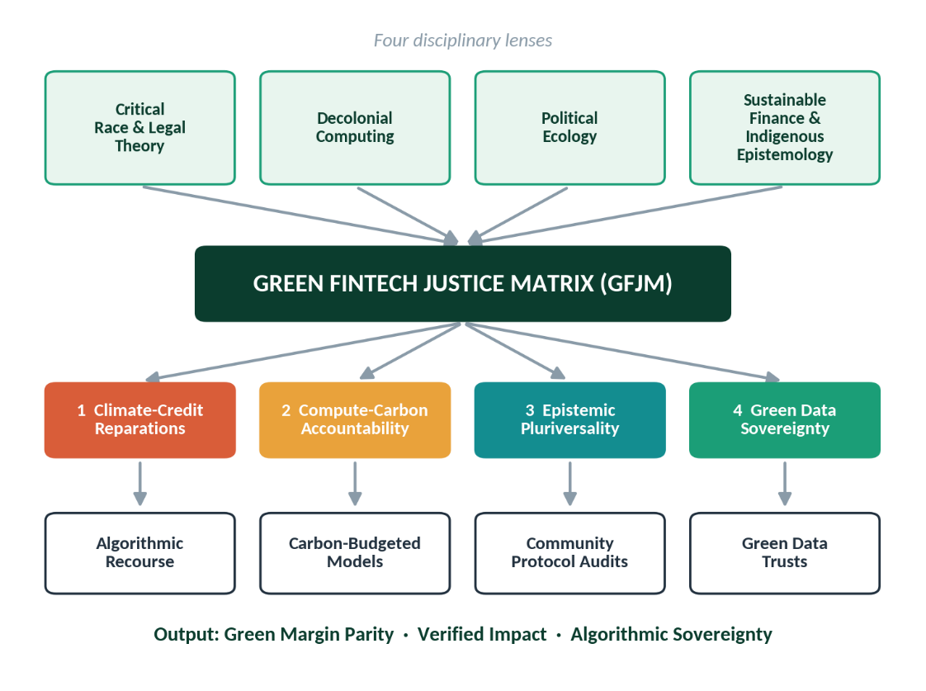
Figure 1. The Green Fintech Justice Matrix: lenses, pillars and mechanisms.
Pillar | Core requirement | Intellectual root
1. Climate-Credit Reparations | Build historical power asymmetries into model design and reallocate decision authority and capital toward climate-exposed groups, instead of debiasing after training | Critical Race and Legal Theory; (1978-, 2019)
2. Compute-Carbon Accountability | Evaluate the full supply chain of any green-fintech stack, from mining to inference, and cap model footprint against the abatement it finances | Political Ecology; (Strubell et al., 2019)
3. Epistemic Pluriversality | Admit local, indigenous and community-held ontologies of risk and value as legitimate model inputs, not noise (Fricker, 2007) | Decolonial Computing; Mohamed et al. (2020)
4. Green Data Sovereignty | Separate identity from data; communities hold governance and licensing rights over data used to certify climate value | Indigenous data governance; STS
Table 2. The four GFJM pillars.

3.1 Testable Propositions
To connect the matrix to organisational research on green fintech, we state five propositions that can be tested with panel, experimental or case-comparative designs.
# | Proposition | Boundary condition
P1 | Community-verified green transparency raises substantive ESG outcomes more than disclosure volume alone | Moderated by Regulatory Stringency
P2 | Green algorithms may improve green decision quality by strengthening ethical judgment among model owners, particularly where governance oversight mechanisms are present. | Mediated by Ethical Judgment
P3 | Community protocol audits increase stakeholder trust, which in turn lowers the Green Margin Gap | Mediated by Stakeholder Trust
P4 | Board green competence strengthens the effect of carbon-budgeted models on the Compute-Carbon Ratio | Moderated by Board Green Competence
P5 | Green data sovereignty reduces algorithmic greenwashing exposure, lowering litigation and enforcement risk | Strongest where data quality in the supply chain is high
Table 3. Propositions linking GFJM to organisational constructs.

4. Operationalising Epistemic Techno-Justice
We pair each pillar with an institutional mechanism (Table 4) and a measurable index (Table 5), so that justice claims can be audited in the way that capital-adequacy ratios are.
Mechanism | Stage | Design
Community Protocol Audits | Pre-deployment | Participatory action research with binding veto for impacted communities over green-scoring and MRV models used in public or subsidised programmes. Audit reports are published in local languages.
Green Data Trusts | Data ownership | Locally governed trusts hold copyright, governance and licensing authority over farm, forest and energy datasets. A reciprocity ledger returns a share of carbon-credit and green-bond proceeds to the trust.
Carbon-Budgeted Models | Sustainability requirement | Every model carries a lifecycle carbon and water budget, disclosed beside its accuracy. Lightweight open-weight models on edge compute are preferred where accuracy loss is small.
Algorithmic Recourse | Redress | Binding legal routes to contest automated green-credit and verification decisions, with human-in-the-loop review, counterfactual explanations and transparent audit trails.
Table 4. Institutional mechanisms.

4.1 The GFJM Scorecard: Four Novel Indices
Index | Definition | Reads as
Green Margin Gap (GMG) | Risk-adjusted effective green-loan rate in the highest climate-vulnerability tier minus the rate in the lowest tier | 0 pp = parity; higher = double-margin penalty
Carbon Redlining Index (CRI) | 1 − (risk-adjusted approval rate in vulnerable areas ÷ approval rate in reference areas) | 0 = no redlining; 1 = total exclusion
Compute-Carbon Ratio (CCR) | Lifecycle kgCO2e of the model stack ÷ tCO2e of verified abatement it finances | Lower = more frugal per unit of impact
Algorithmic Green Sovereignty Score (AGSS) | Weighted pass-rate on four tests: community data ownership, binding veto, recourse resolution, local-ontology inclusion | 0 to 100; higher = more community control
Table 5. The GFJM Scorecard.

4.2 Where the Pillars Bite Hardest
Not every green-fintech product stresses each pillar equally. Figure 2 maps five use cases against the four pillars to help regulators and developers prioritise audit effort.
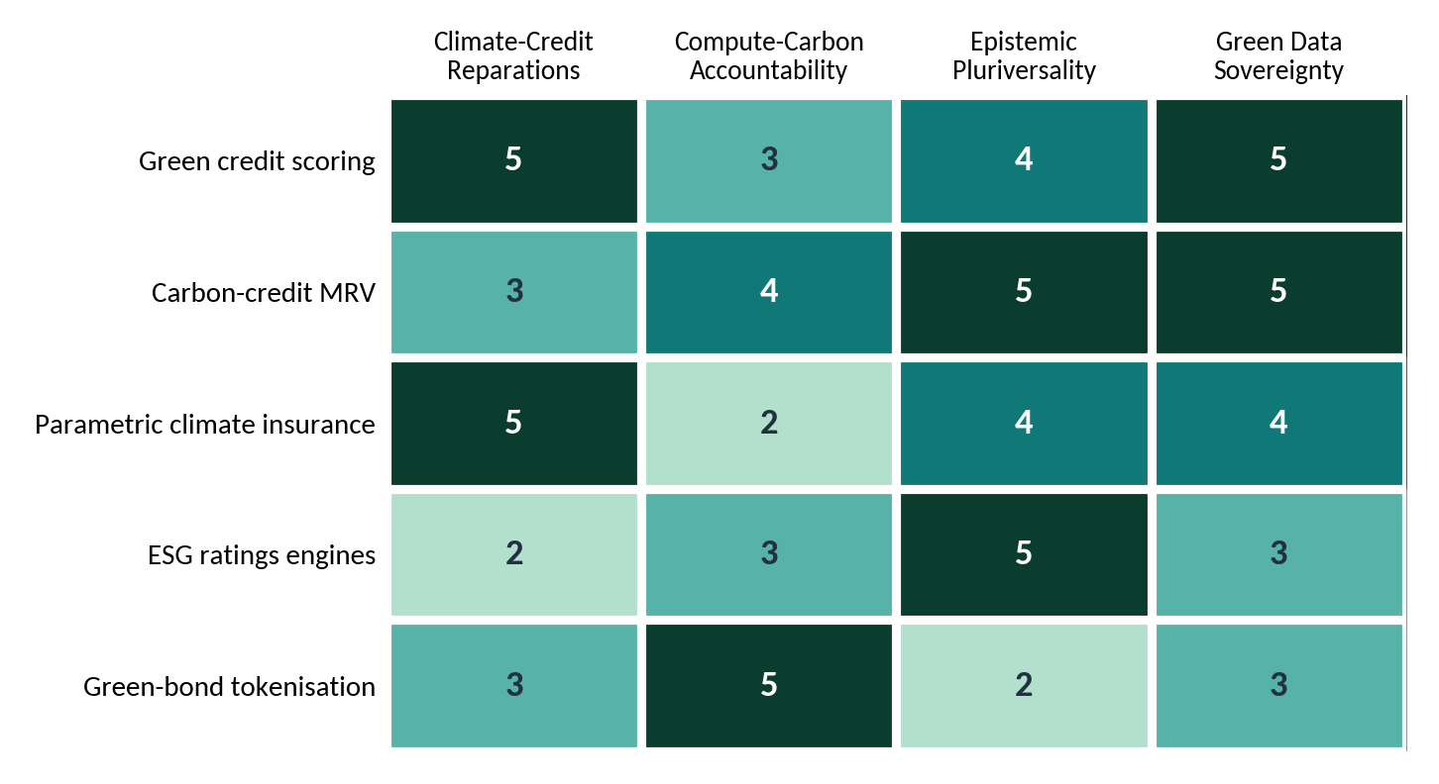
Figure 2. Priority of each GFJM pillar by green-fintech use case (1 = low, 5 = critical).
Conceptual expert-judgement scoring by the authors; intended as a prioritisation aid to be refined empirically. Done

5. Illustrative Evidence: Modelling the Interruption of the Double Margin
To show how the scorecard would behave, we parameterise a stylised portfolio of green loans across four climate-vulnerability tiers. These values are illustrative assumptions chosen to demonstrate the mechanics of the framework; they are not drawn from a dataset and should not be read as empirical results. A first empirical test could use difference-in-differences around the introduction of a community audit or recourse rule.
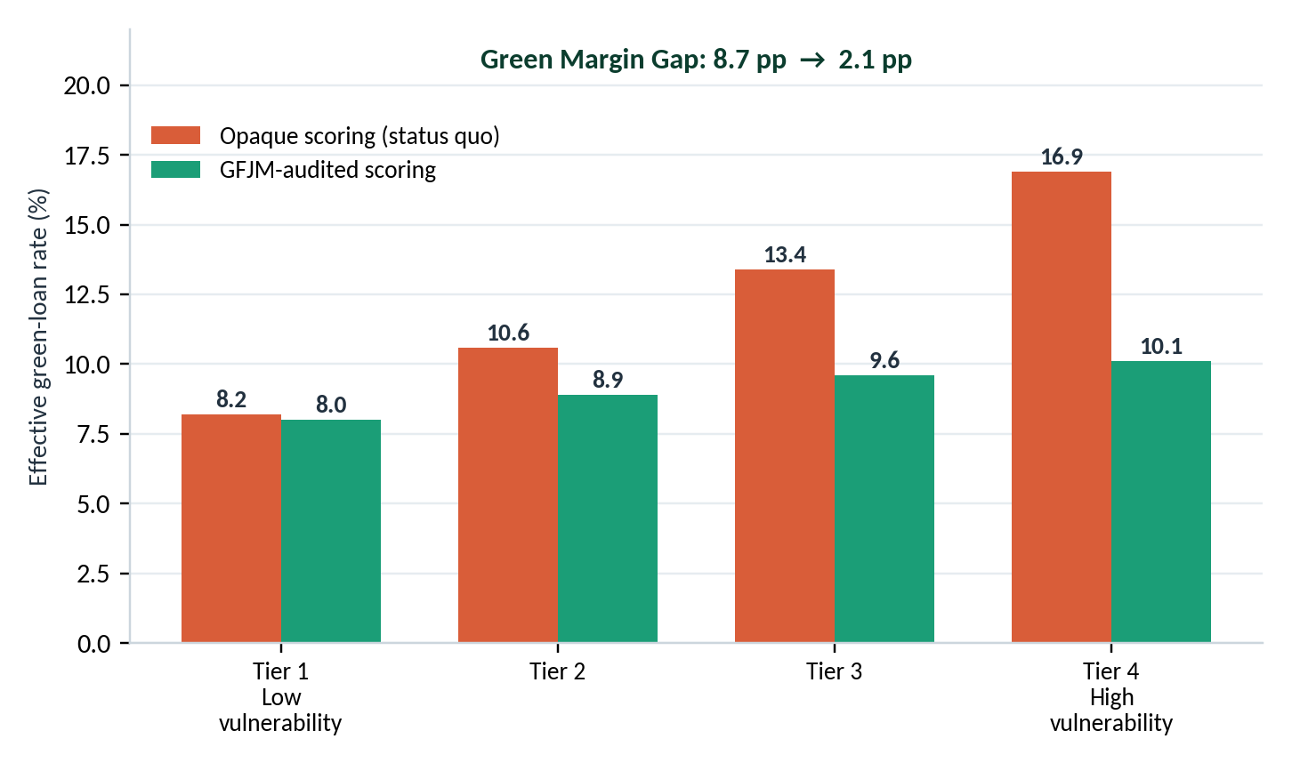
The following simulations are conceptual demonstrations intended to illustrate the mechanics of GFJM. They do not constitute empirical validation, causal evidence, or predictive modelling results
Figure 3. Effective green-loan rate by climate-vulnerability tier under opaque and GFJM-audited scoring.
Illustrative simulation. GMG = 16.9 − 8.2 = 8.7 pp (status quo) and 10.1 − 8.0 = 2.1 pp (GFJM).
Under opaque scoring, the effective rate rises steadily with vulnerability, producing a Green Margin Gap of 8.7 percentage points. Under audited scoring that admits community-defined resilience indicators and requires recourse, the gap narrows to 2.1 points while the low-vulnerability tier barely changes, so the correction is redistributive rather than a blanket subsidy.
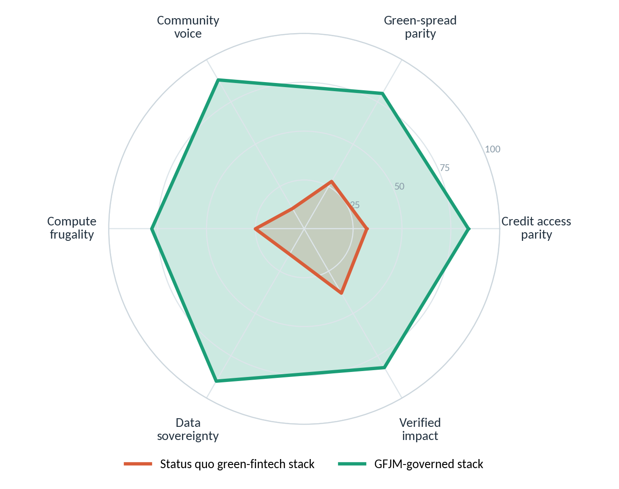
Figure 4. Six-dimension governance profile of a status quo versus a GFJM-governed green-fintech stack.
Figure 4 summarises the broader governance profile. The largest illustrative gains are on community voice and data sovereignty, the two dimensions that technical fairness fixes rarely touch.
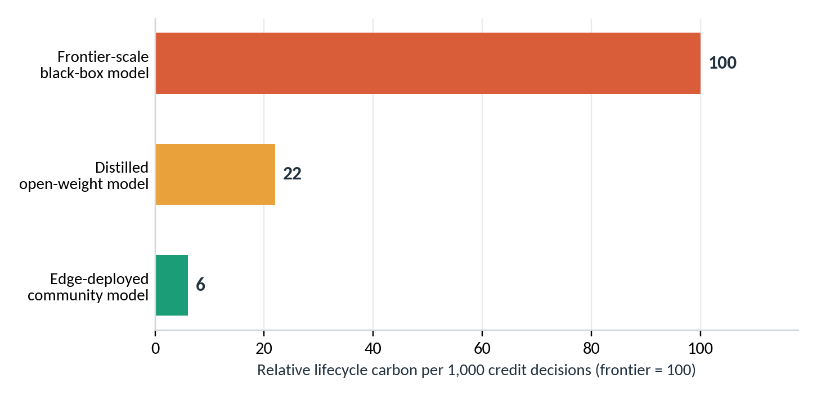
Figure 5. Relative lifecycle carbon per 1,000 credit decisions by model architecture (frontier = 100).
Illustrative index values; to be replaced by measured lifecycle assessments.
Figure 5 makes pillar 2 concrete. Because a green-fintech model that finances abatement while emitting heavily is itself a form of greenwashing, the Compute-Carbon Ratio treats model footprint as a first-order performance metric rather than an externality.

6. Case Scenarios: Redesigning Green-Fintech Systems

The scenarios are illustrative design examples rather than observed implementations. They are intended to demonstrate potential governance redesign opportunities and require empirical evaluation.
Scenario | Status quo | GFJM intervention
A. Green credit for smallholders and MSMEs | Opaque climate-risk scores widen spreads for exposed farms; alternative data is harvested without return | Community-defined vulnerability and resilience indexes; green data trust with a reciprocity ledger; recourse for contested scores
B. Carbon-credit markets and digital MRV | Satellite and AI verification is proprietary; forest communities supply ground truth but receive little of the credit value | Community oracles co-verify outputs; binding benefit-sharing through the trust; published model carbon budget
C. Parametric climate insurance | Index triggers calibrated on urban or insured-asset data miss rural loss patterns; payouts are slow or denied | Pluriversal trigger design using local ontologies of loss; community audit before deployment; deterministic, open triggers
Table 6. Redesigning three green-fintech systems.

7. Research Agenda and Limitations
- Measurement: operationalising the four indices requires risk-adjusted lending data, lifecycle assessments of model stacks and community-validated sovereignty tests.
- Identification: audit or recourse mandates could provide quasi-experimental variation for difference-in-differences designs.
- Trade-offs: frugal models may sacrifice some predictive accuracy; the appropriate accuracy-footprint frontier is a normative choice for affected communities, not only for modellers.
- Governance risk: community bodies can be captured. Rotating membership, independent technical support and transparent funding are design necessities.
- Limitations: the quantitative evidence here is illustrative, and the propositions are untested.

8. Conclusion: Toward Just Green Finance
Decarbonisation cannot be financed on terms that deepen the exposure of those who contributed least to the crisis. Retrofitting green-fintech models with superficial fairness constraints will not interrupt the double margin. The Green Fintech Justice Matrix offers an alternative: treat marginality as enclosure, pair every pillar with a mechanism and a measurable index, and strengthen community participation and accountability mechanisms within climate-finance governance systems that hold the evidence on which green value is certified. If the algorithmic margin is reclaimed, green fintech can become an instrument of collective adaptation rather than another frontier of extraction.
References:
Bartlett, R., Morse, A., Stanton, R., & Wallace, N. (2022). Consumer-lending discrimination in the FinTech era. Journal of Financial Economics, 143(1), 30–56.
Berg, F., Kölbel, J. F., & Rigobon, R. (2022). Aggregate confusion: The divergence of ESG ratings. Review of Finance, 26(6), 1315–1344.
Carroll, S. R., Garba, I., Figueroa-Rodríguez, O. L., Holbrook, J., Lovett, R., Materechera, S., Parsons, M., Raseroka, K., Rodriguez-Lonebear, D., Rowe, R., Sara, R., Walker, J. D., Anderson, J., & Hudson, M. (2020). The CARE principles for Indigenous data governance. Data Science Journal, 19(1), Article 43.
Couldry, N., & Mejias, U. A. (2019). The costs of connection: How data is colonizing human life and appropriating it for capitalism. Stanford University Press.
de Vries-Gao, A. (2025). The carbon and water footprints of data centers and what this could mean for artificial intelligence. Patterns. †
Demirgüç-Kunt, A., Klapper, L., Singer, D., & Ansar, S. (2022). The Global Findex Database 2021: Financial inclusion, digital payments, and resilience in the age of COVID-19. World Bank.
Ensign, D., Friedler, S. A., Neville, S., Scheidegger, C., & Venkatasubramanian, S. (2018). Runaway feedback loops in predictive policing. Proceedings of Machine Learning Research, 81, 160–171.
Fazelpour, S., & Danks, D. (2021). Algorithmic bias: Senses, sources, solutions. Philosophy Compass, 16(8), Article e12760.
Fourcade, M., & Healy, K. (2017). Seeing like a market. Socio-Economic Review, 15(1), 9–29.
Fuster, A., Goldsmith-Pinkham, P., Ramadorai, T., & Walther, A. (2022). Predictably unequal? The effects of machine learning on credit markets. The Journal of Finance, 77(1), 5–47.
Islam, M. M. (2022). Distributive justice in global climate finance: Recipients’ climate vulnerability and the allocation of climate funds. Global Environmental Change, 73, Article 102475. †
Rothstein, R. (2017). The color of law: A forgotten history of how our government segregated America. Liveright.
Sadowski, J. (2019). When data is capital: Datafication, accumulation, and extraction. Big Data & Society, 6(1).
Venner, K., et al. (2024). The multi-scalar inequities of climate adaptation finance: A critical review. Current Climate Change Reports. †
West, T. A. P., Börner, J., Sills, E. O., & Kontoleon, A. (2020). Overstated carbon emission reductions from voluntary REDD+ projects in the Brazilian Amazon. Proceedings of the National Academy of Sciences, 117(39), 24188–24194.
Xiao, T., et al. (2025). Environmental impact and net-zero pathways for sustainable artificial intelligence servers in the USA. Nature Sustainability. †
Zuboff, S. (2019). The age of surveillance capitalism: The fight for a human future at the new frontier of power. PublicAffairs.

